**Azure Application gateway**

It is limited one and it will allow traffic only http and https port

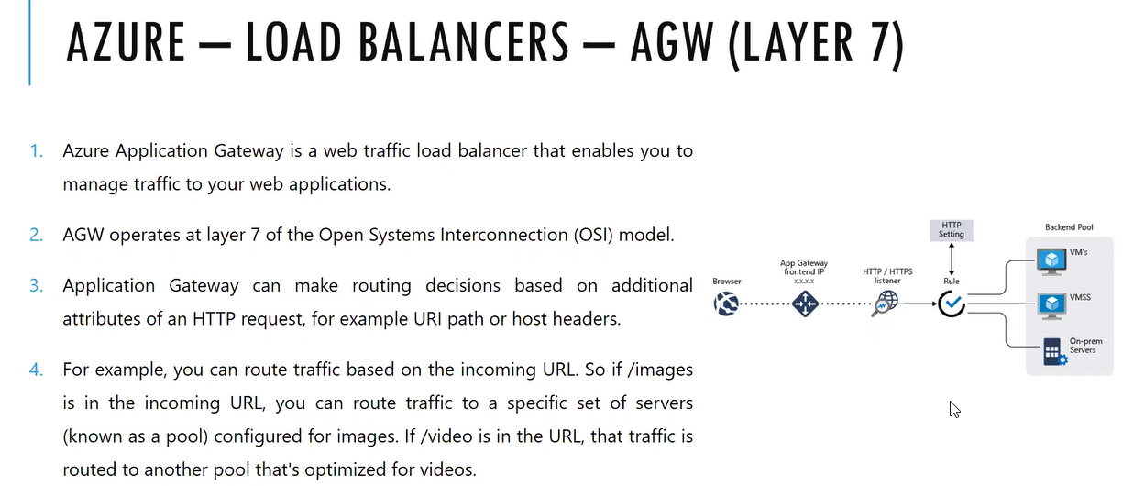

It will not forward the request as it as like load balancing to backend instances. Source(request) based on it will forward the traffic that means path based routing in the URL if there is keyword end user enters the url in the browser navigates to my profile, videos or audio something any key word will be added in a path based on the keyword it will forward the request to backend pools

One load balancer one application gate way it will support multiple websites in a single instance similar to azure load balancer

Based on the URL/domain (end user) it will select the backend pool that is host based routing

Routing capabilities applies to only application gateway.

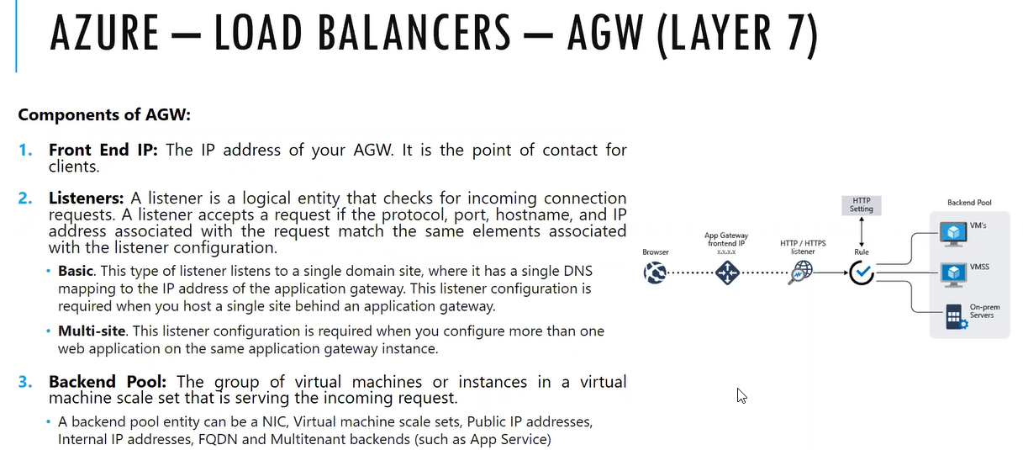

Listeners : it will monitor the request from front end user. It will listen the incoming connection and analyze the which website it got the request

Basic listener: it will handle only one web site

Backend pool it will forward request to backend pool from listeners

If listener wants to take decision, then we need to define the rules

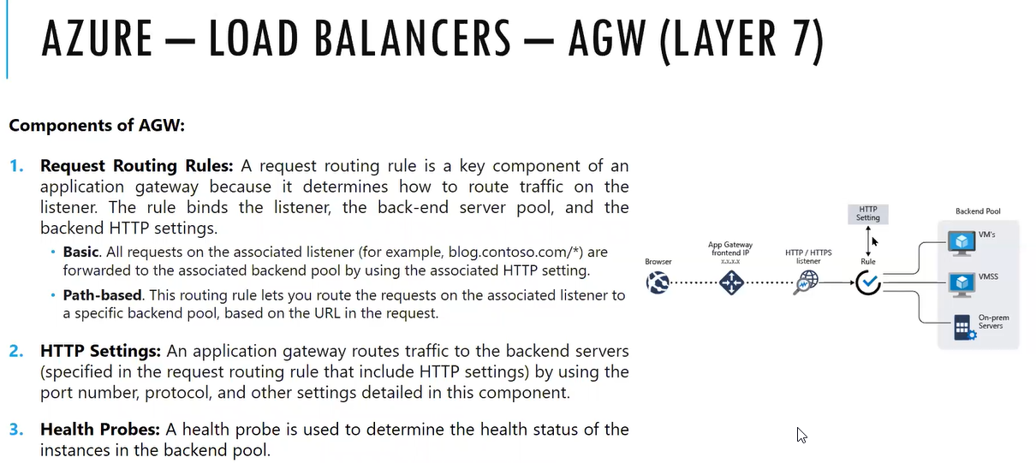

Load balancer will support connection to virtual machines and scale set where as application gateway will support connection to virtual machines, on premises(in the drop down we have an ip address) and scale set

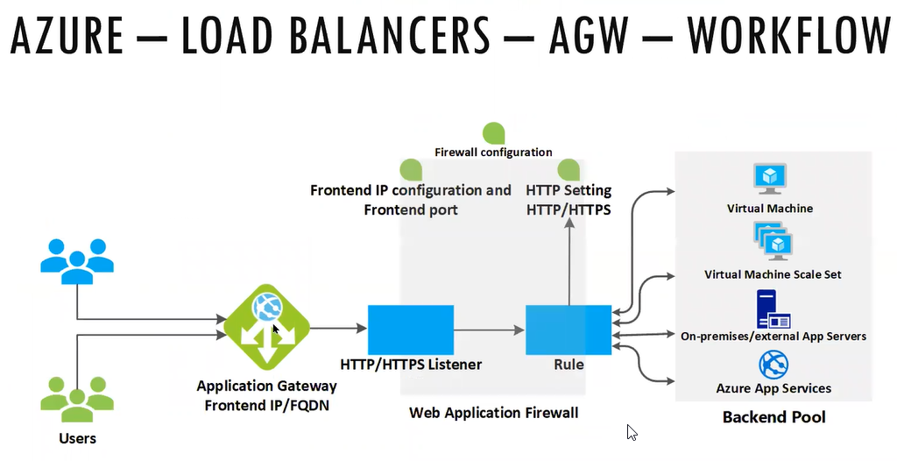

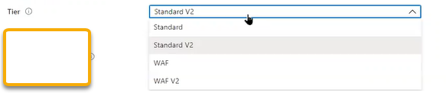

Standard is basic supports basic listener and standard v2 is standard supports multi listener

WAF is web application firewall. Specially application gateway we are using to handling the web application traffic. So, in that case we need protection for web application. For virtual machines we have DDOS Protection.

**Web application firewall is kind of intrusion detection** system (**IDS**)

OWASP ( type in Google we will results ) will be present in all the firewalls

**Top 10 Web Application Security Risks**

1. [**Injection**](https://owasp.org/www-project-top-ten/2017/A1_2017-Injection). Injection flaws, such as SQL, NoSQL, OS, and LDAP injection, occur when untrusted data is sent to an interpreter as part of a command or query. The attacker’s hostile data can trick the interpreter into executing unintended commands or accessing data without proper authorization.
2. [**Broken Authentication**](https://owasp.org/www-project-top-ten/2017/A2_2017-Broken_Authentication). Application functions related to authentication and session management are often implemented incorrectly, allowing attackers to compromise passwords, keys, or session tokens, or to exploit other implementation flaws to assume other users’ identities temporarily or permanently.
3. [**Sensitive Data Exposure**](https://owasp.org/www-project-top-ten/2017/A3_2017-Sensitive_Data_Exposure). Many web applications and APIs do not properly protect sensitive data, such as financial, healthcare, and PII. Attackers may steal or modify such weakly protected data to conduct credit card fraud, identity theft, or other crimes. Sensitive data may be compromised without extra protection, such as encryption at rest or in transit, and requires special precautions when exchanged with the browser.
4. [**XML External Entities (XXE)**](https://owasp.org/www-project-top-ten/2017/A4_2017-XML_External_Entities_(XXE)). Many older or poorly configured XML processors evaluate external entity references within XML documents. External entities can be used to disclose internal files using the file URI handler, internal file shares, internal port scanning, remote code execution, and denial of service attacks.
5. [**Broken Access Control**](https://owasp.org/www-project-top-ten/2017/A5_2017-Broken_Access_Control). Restrictions on what authenticated users are allowed to do are often not properly enforced. Attackers can exploit these flaws to access unauthorized functionality and/or data, such as access other users’ accounts, view sensitive files, modify other users’ data, change access rights, etc.
6. [**Security Misconfiguration**](https://owasp.org/www-project-top-ten/2017/A6_2017-Security_Misconfiguration). Security misconfiguration is the most commonly seen issue. This is commonly a result of insecure default configurations, incomplete or ad hoc configurations, open cloud storage, misconfigured HTTP headers, and verbose error messages containing sensitive information. Not only must all operating systems, frameworks, libraries, and applications be securely configured, but they must be patched/upgraded in a timely fashion.
7. [**Cross-Site Scripting (XSS)**](https://owasp.org/www-project-top-ten/2017/A7_2017-Cross-Site_Scripting_(XSS)). XSS flaws occur whenever an application includes untrusted data in a new web page without proper validation or escaping, or updates an existing web page with user-supplied data using a browser API that can create HTML or JavaScript. XSS allows attackers to execute scripts in the victim’s browser which can hijack user sessions, deface web sites, or redirect the user to malicious sites.
8. [**Insecure Deserialization**](https://owasp.org/www-project-top-ten/2017/A8_2017-Insecure_Deserialization). Insecure deserialization often leads to remote code execution. Even if deserialization flaws do not result in remote code execution, they can be used to perform attacks, including replay attacks, injection attacks, and privilege escalation attacks.
9. [**Using Components with Known Vulnerabilities**](https://owasp.org/www-project-top-ten/2017/A9_2017-Using_Components_with_Known_Vulnerabilities). Components, such as libraries, frameworks, and other software modules, run with the same privileges as the application. If a vulnerable component is exploited, such an attack can facilitate serious data loss or server takeover. Applications and APIs using components with known vulnerabilities may undermine application defenses and enable various attacks and impacts.
10. [**Insufficient Logging & Monitoring**](https://owasp.org/www-project-top-ten/2017/A10_2017-Insufficient_Logging%2526Monitoring). Insufficient logging and monitoring, coupled with missing or ineffective integration with incident response, allows attackers to further attack systems, maintain persistence, pivot to more systems, and tamper, extract, or destroy data. Most breach studies show time to detect a breach is over 200 days, typically detected by external parties rather than internal processes or monitoring.

Any company will expose outside is web applications, websites mobile app

Firewall mode: Detection, prevention. If virus will attack the machine, then it will send the notification that there is virus and if it prevents the machine from virus that means even it does not attack the machine. If we keep prevention as an option then if there is known packets causing some issues then it will stop it which is again a problem

IDS and IPS tools to protect the network. (Intrusion detect system and Intrusion prevent system)

HTTP2: is for supporting long running applications. If you give the limit in webserver then up to that point application will be running. We will communicate with development team and accordingly we will enable the option

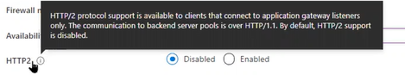

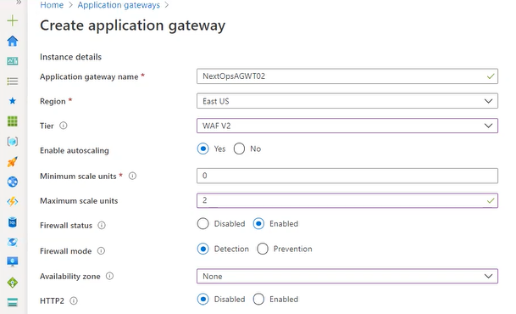

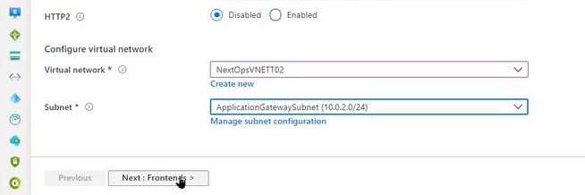

The requirement for application gateway is it does not require named subnet ( does not want VM Placement) and it requires unnamed subnet

So, create the new one

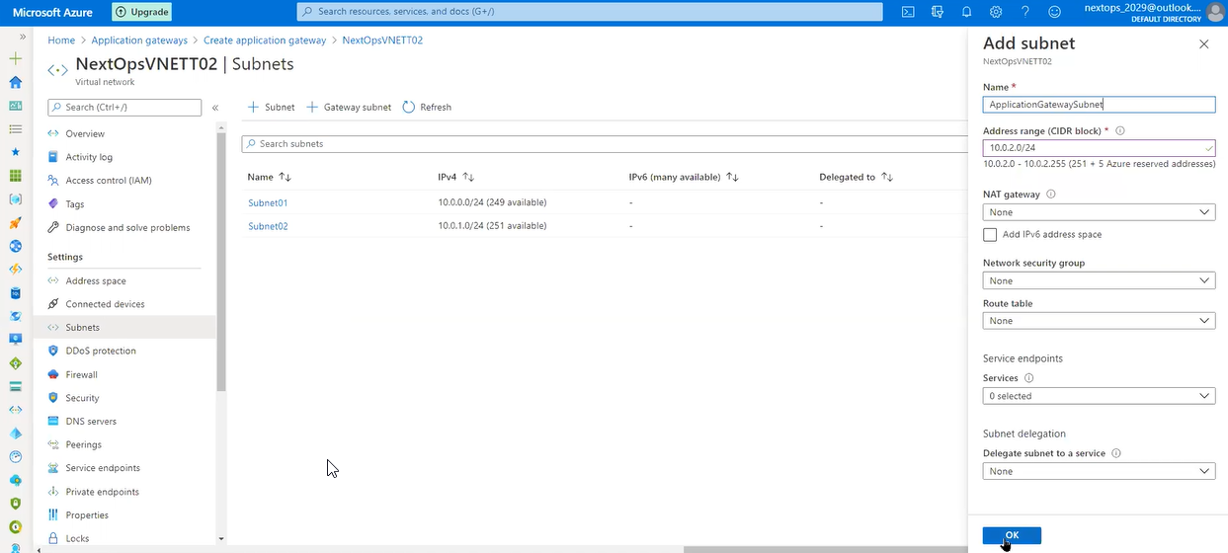

WAF 2 will supports public and private frontend and NOT Both

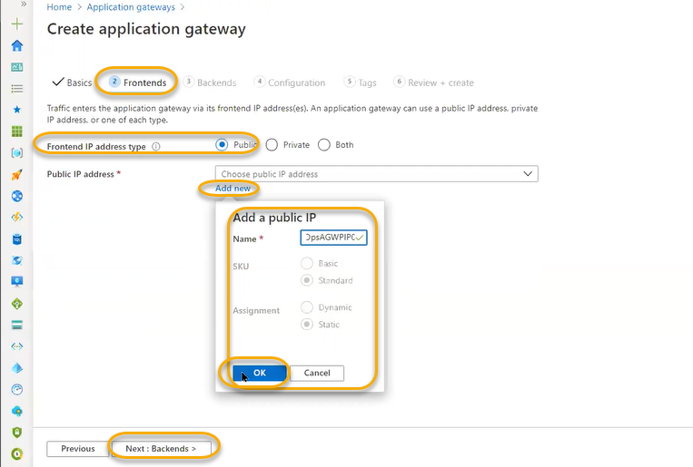

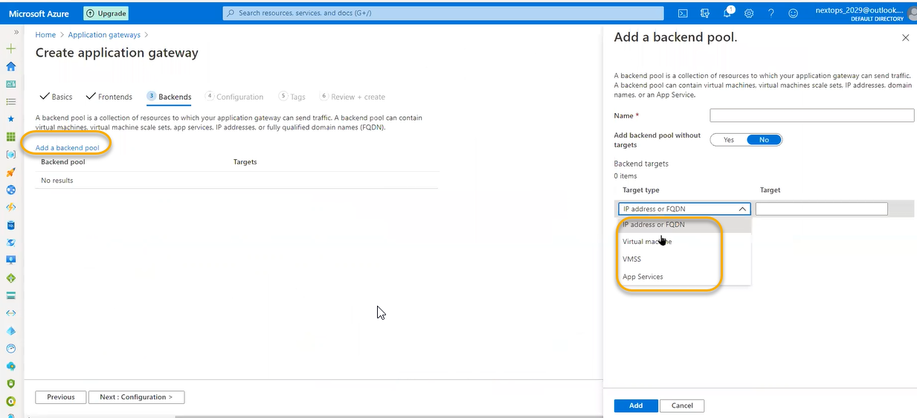

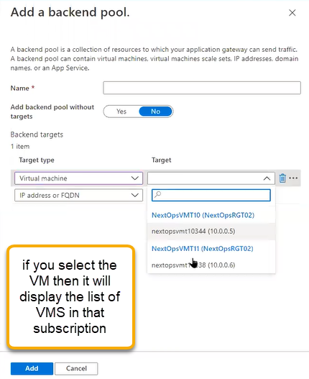

If you select VMSS then it will display the available scale set in the azure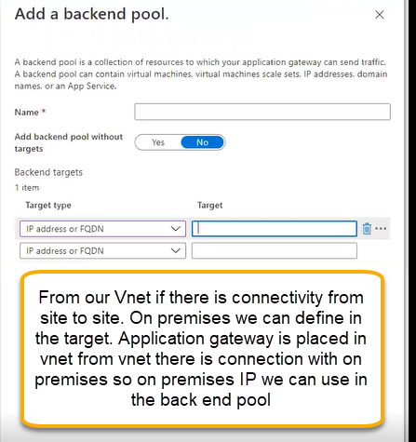

Or if the machine has public ip which is placed in customer network we can place here

App services: resources availble in azure we can use them as a backend pool

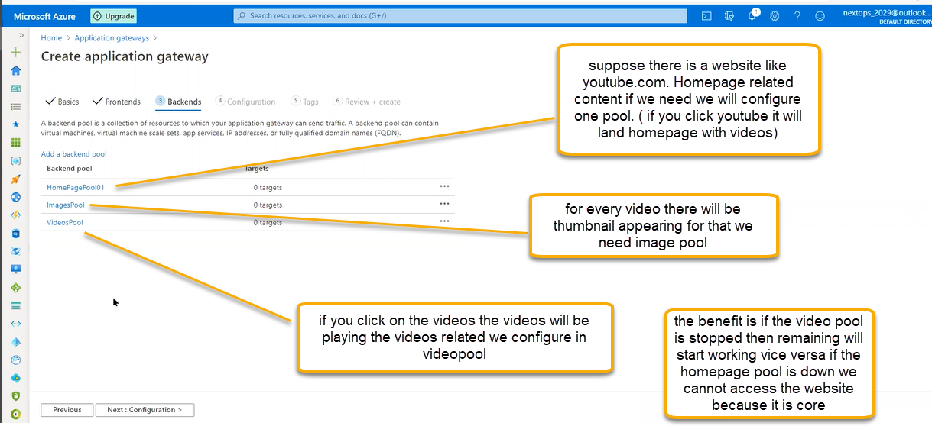

We will assign 2 servers to homepool and 1 server to image and 1 to video pool how the request will route we can see later

Configuration Routing rules is the connection between frontend and backend pool along with listener configuration will start.

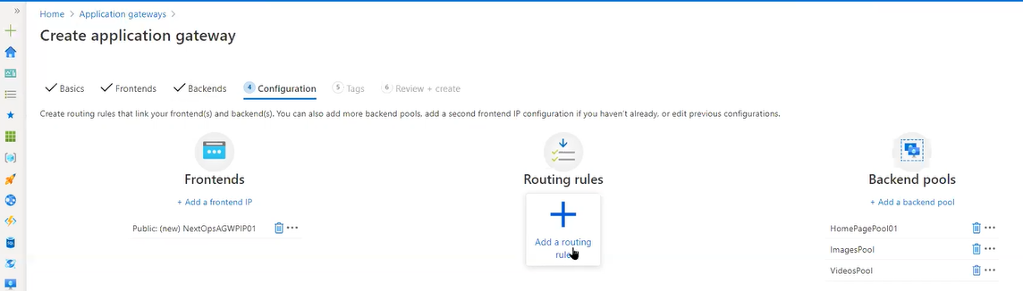

Frontend IP: listener - where to get the coming request through frontend IP he has to take the request

If he selects protocol HTTPS: then he has to select the certificate which he access from key vaults or he can upload from machine as shown below if you select HTTPS then option will be enabled to select the certificate from the keyvault or we can manually upload the certificate

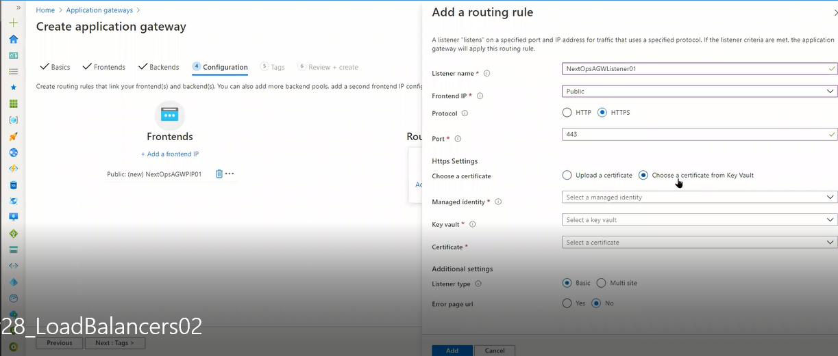

Error page url: if he cannot access the website in case for the end user if get the messages like 502 and 403 then it will display the custom image, we can mention the URL in the 502 and 403 boxes.

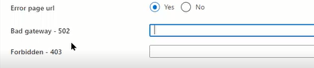

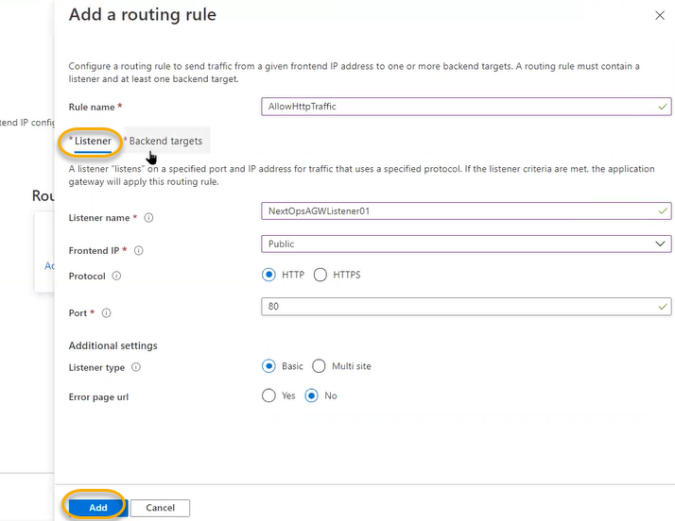

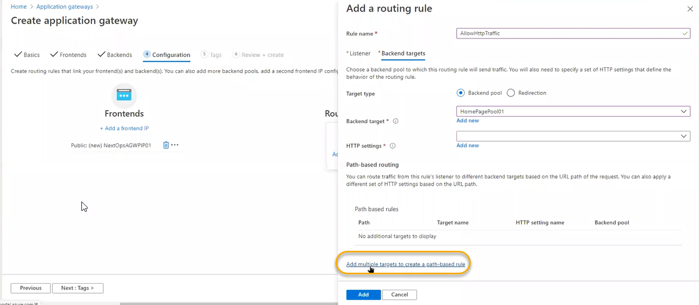

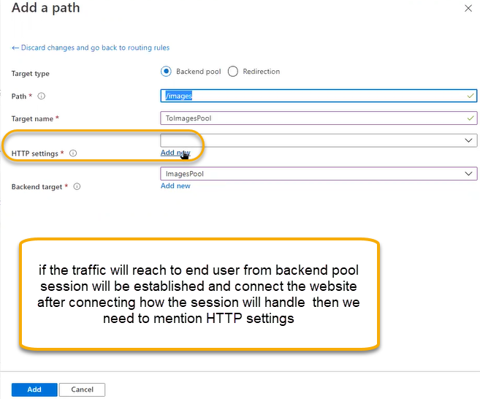

Cookie based affinity: if you access the websites there will be 100 of cookies will be stored. For one website there will be one cookie. If you access the flip kart and select any mobile phone and we you will not buy and then if you try to access the Facebook or Instagram, then it will show it as ad for flip kart mobile. The process is called provoking. Based on cookies it will display the ads for remaining web sites

Cookies will be saved in text file if you delete the history then cookies will be deleted

So if end user try to access the website for first time then it will go to the first instance and if cookie is enabled and if he gain try to access the web site for the 2nd , 3rd time and 4th time then also it will go to the first instance until we delete the cookies. If we delete the cookies, then it will go to the next instance.

Connection draining: in the backend we have created the instances if one of the instances is down/unhealthy we need to login to VM and must check while checking that in that particular VM if we do any configuration change or operating system upgrade anything connection draining is useful. If you do connection draining, we will set threshold drain time out. Before issues occurring some of the transactions has running so for unhealthy instances the respond will not go it has to tell another instance that my instance is unhealthy and communicate to Load balancer that instance is completely useless removed from backend pool that updating process has to do through out the load balancer configuration, listeners, backend pool we will set threshold drain time out.

In some cases, maintenance will do for healthy machines any patching work has to do like O.S or application so all the instances in backend pool will be removed one by one and do patching and add it.

Even though we will give pull request then it will wait for 5 minutes to one hour and terminate the all existing requests and NOT accept any new request

Request timeout if an end user accesses the website if the response will not come at what time it has time out we can set to 20 to 60 seconds

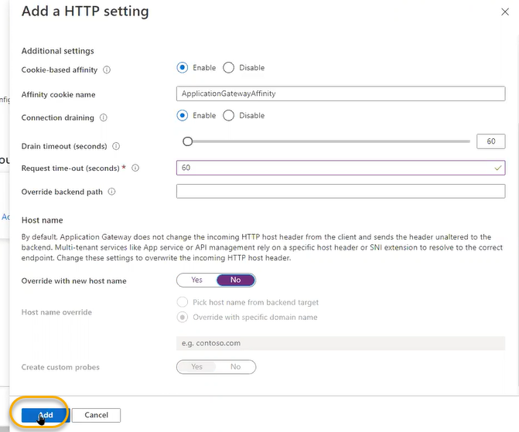

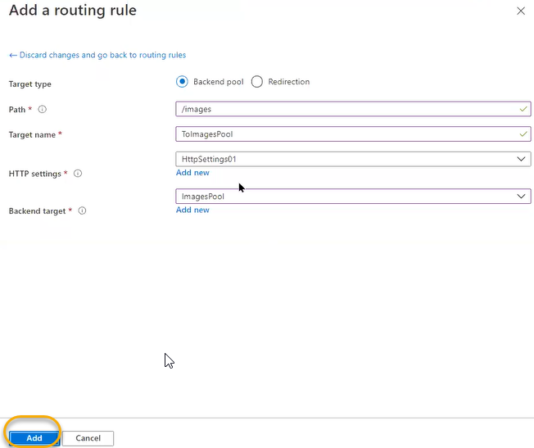

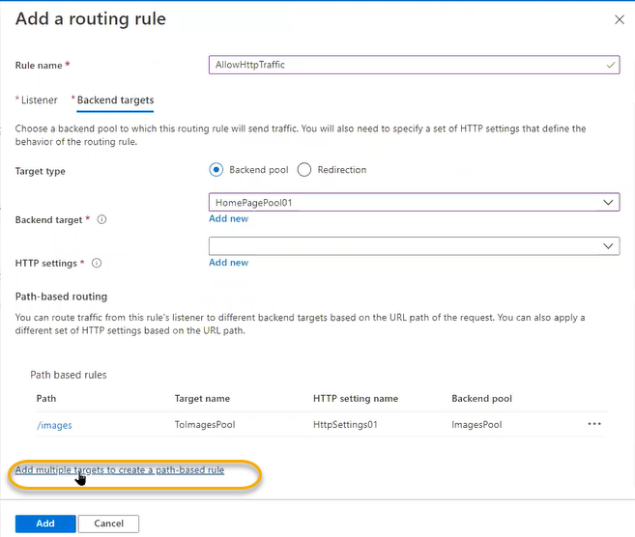

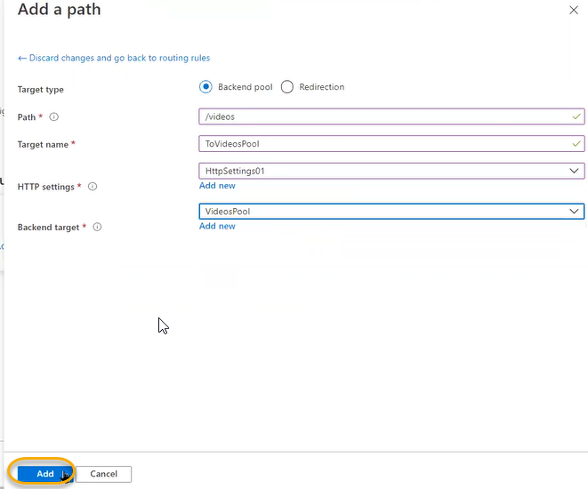

This gateway will work only one website however backend targets directly if end user hits homepage (youtube.com) initial it has to send to homepage, based on keyword message for the respective request forward to set of servers.

Redirection external websites if we need to forward the traffic ( A is a old company B is new company if A will acquires the B. So B website will not present because B is mixed with A so if the user request will come to B then it will forward to A

Click on Add > Add > Review and create

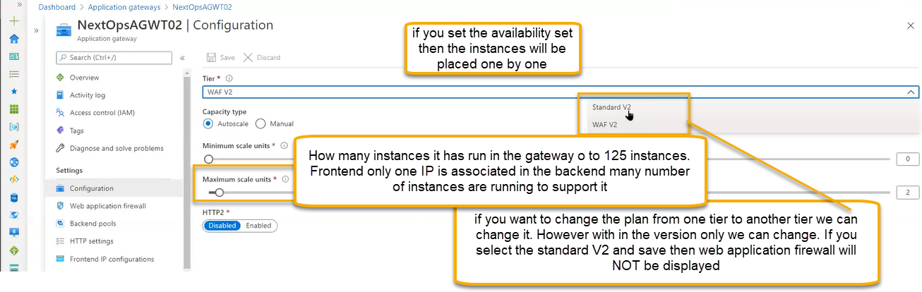

Auto scale: we can define the range between the instances so based on load it will automatically scale up and scale down the instances

Manual Scale: if we kept the fixed range instances how many to run then the instances will be completely running

If your application supports HTTP2: then we can enable which will reflect the additional features

Web application firewall:heart of the application gateway which is designed to this instance

DDOS is Vnet level protection.

If we have any information regarding the source for coming request source information, or they will be header request ( evert http have header request),which protocal has used, particular request has orginated

We can block some request based on the header and if you key word in the selector column like tamilmv we can restrict that site



Inspect request body: the requests will be completly scanned from where the packets are coming

If there is any file upload options available for the web app we can define below

Based on the rules web application firewall will work

Network standpoint most repeated attacks we will see in top 10 owasp rules.

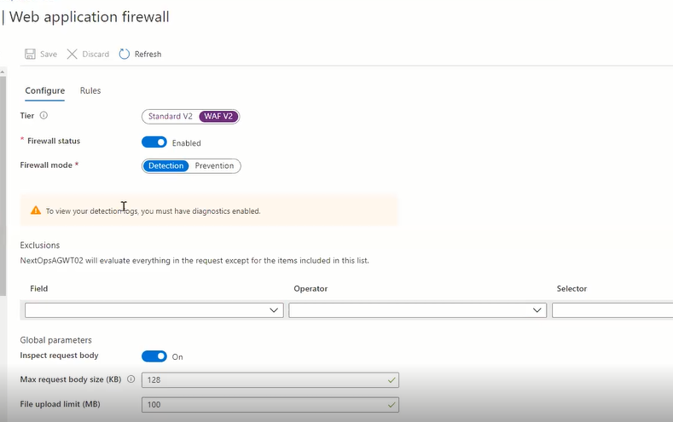

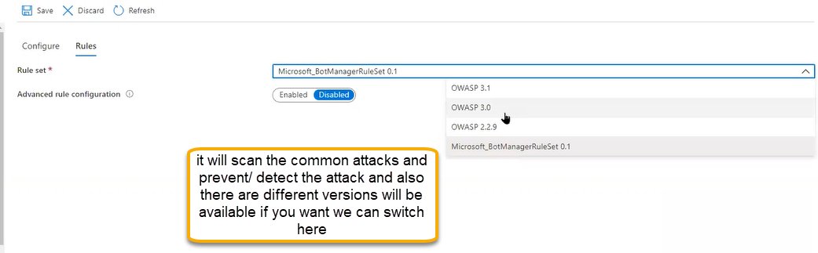

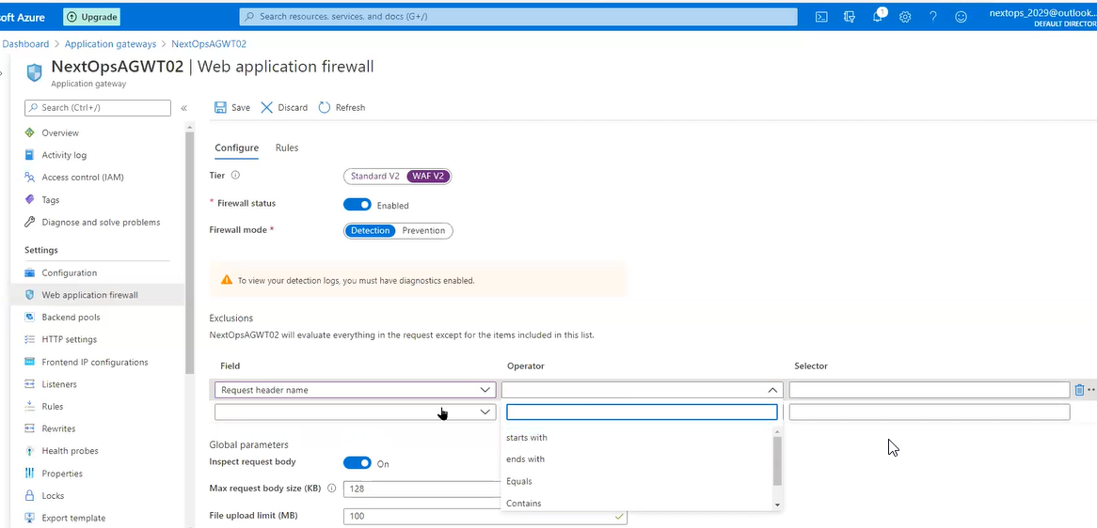

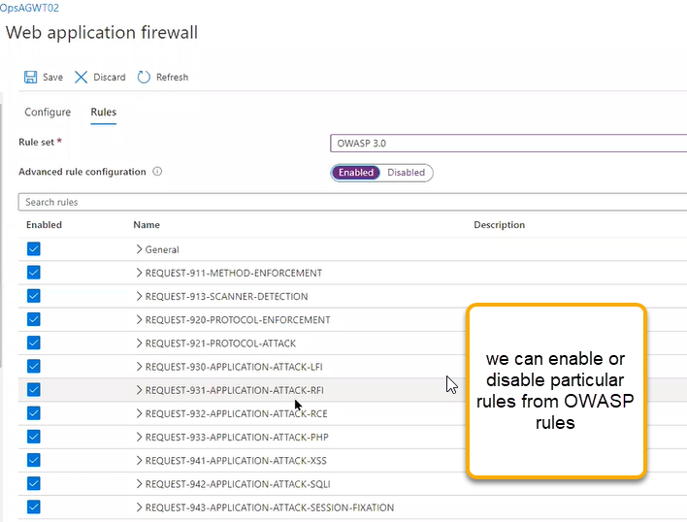

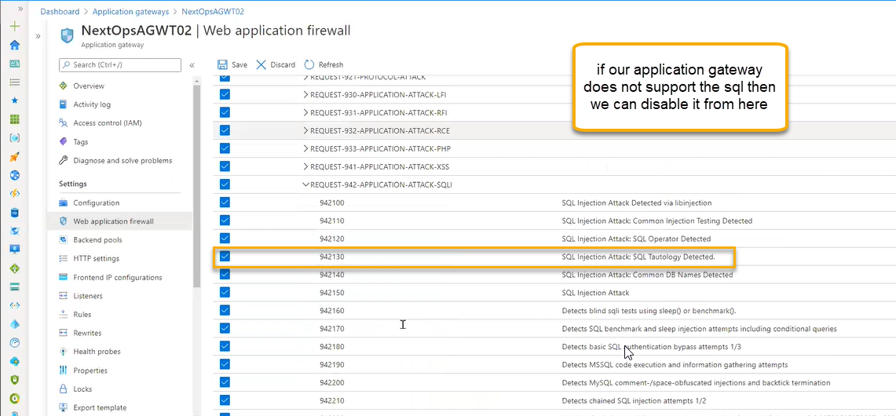

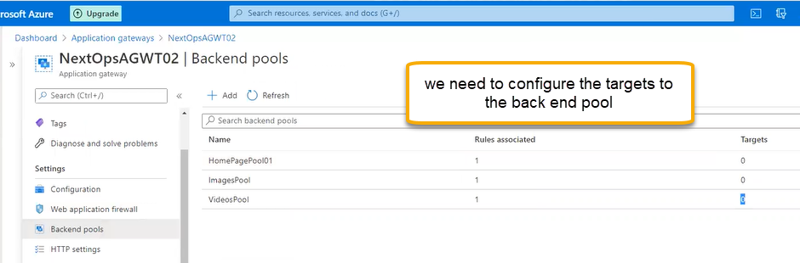

For that we need 4 VMS in place one is for image and one is video and two is for home page

Add the public Ip for one VM which is the main machine. Install the internet services information will added

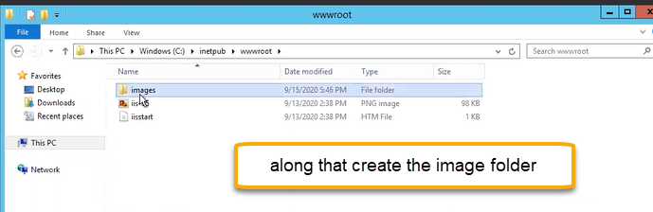

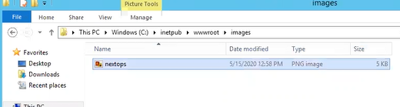

It will give the images location if we execute the below one

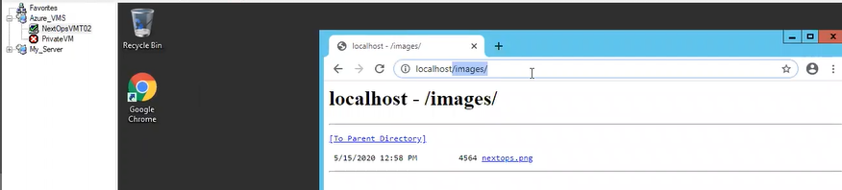

Fourth VM is for videos

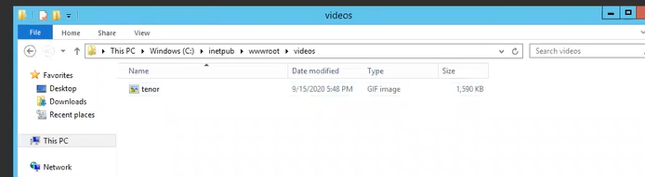

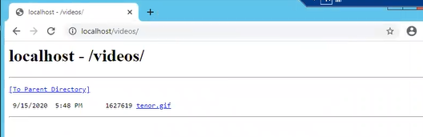

For creating the Images and videos we need to modify the below things

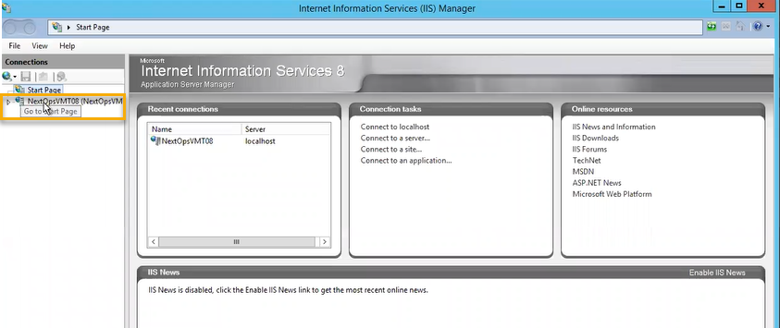

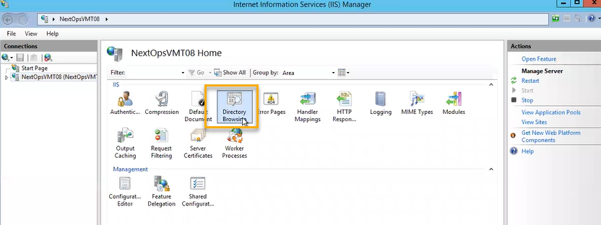

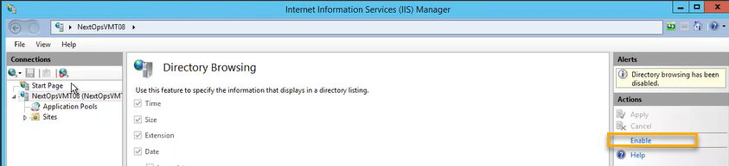

and second VM and third VM is assigned to Private IP and if you google the host then web page will appear and NO folder are created. It is only homepage pool

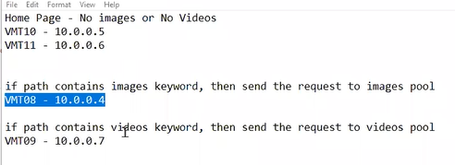

Traffic will be handled in a more efficient way (**mstsc)**

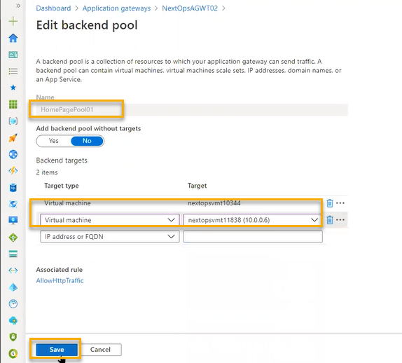

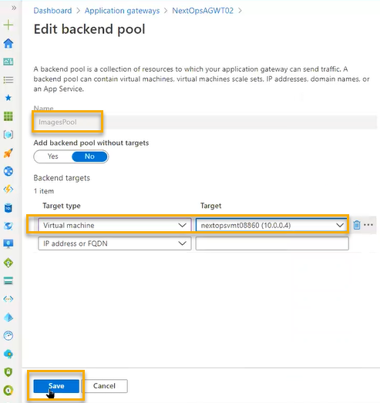

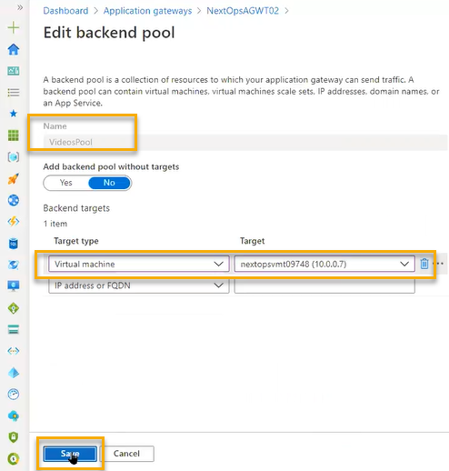

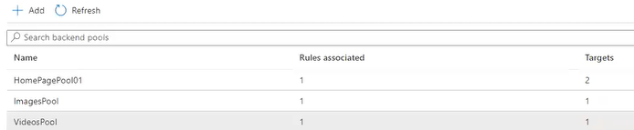

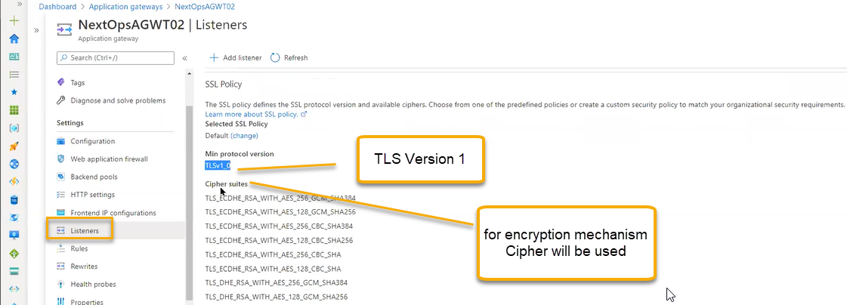

For every website we will have cipher

For production environment we need to disable some of the Cipher and we can do it from IIS Manager if we configure IIS, Apache, Tomcat we can disable it

But for windows there will be tool because we don’t know where to disable cipher files

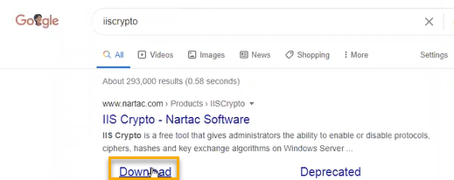

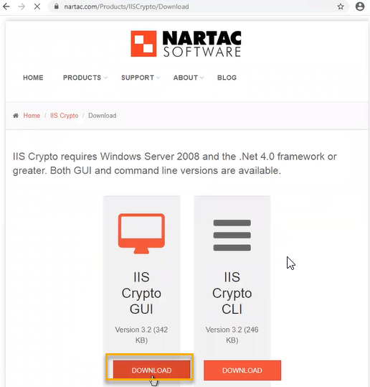

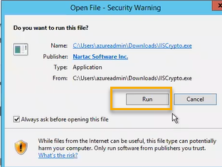

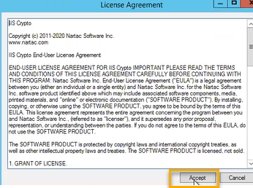

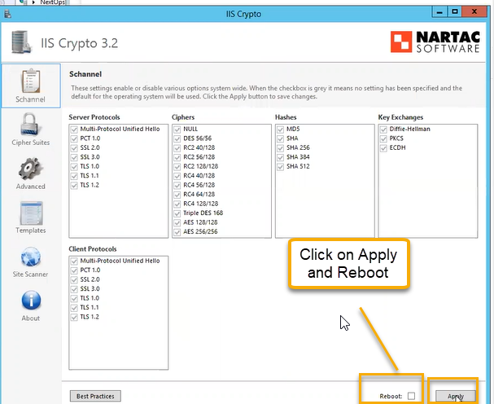

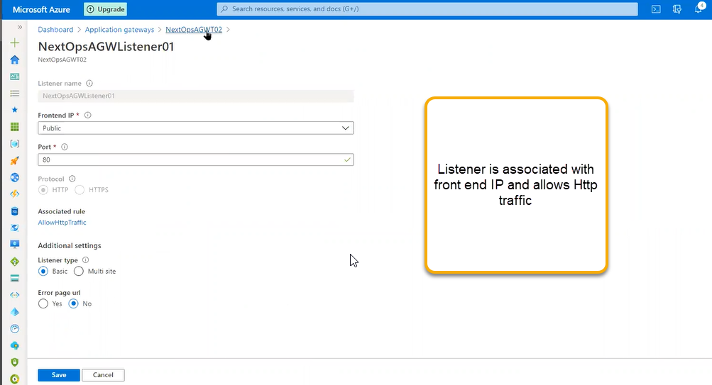

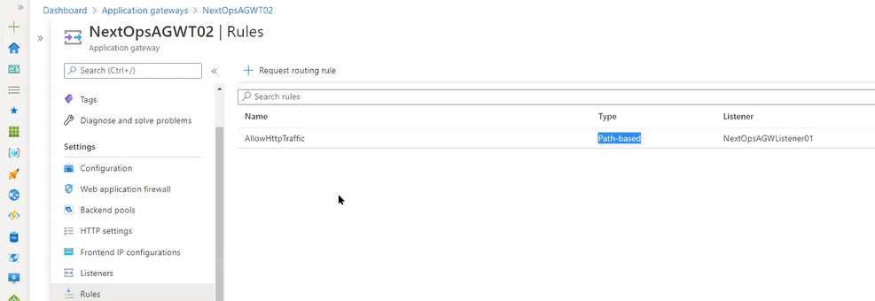

Healthy Probe

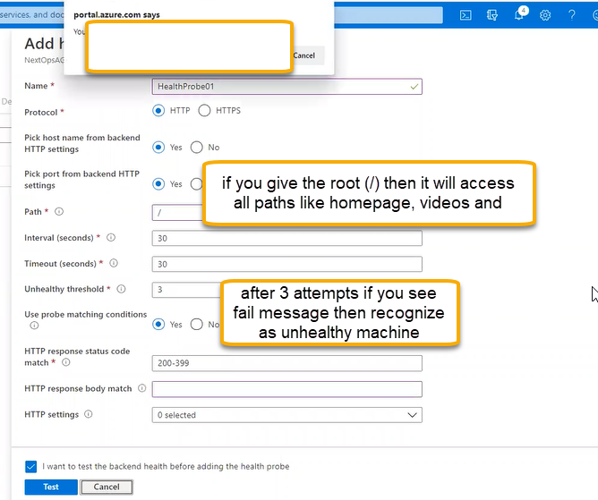

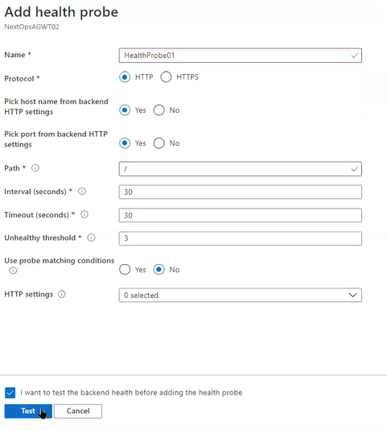

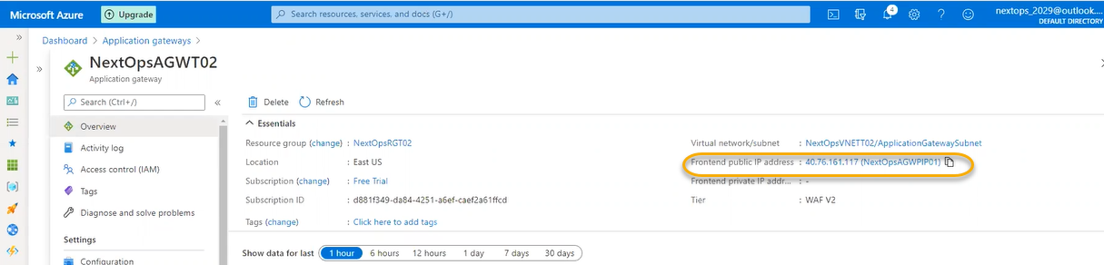

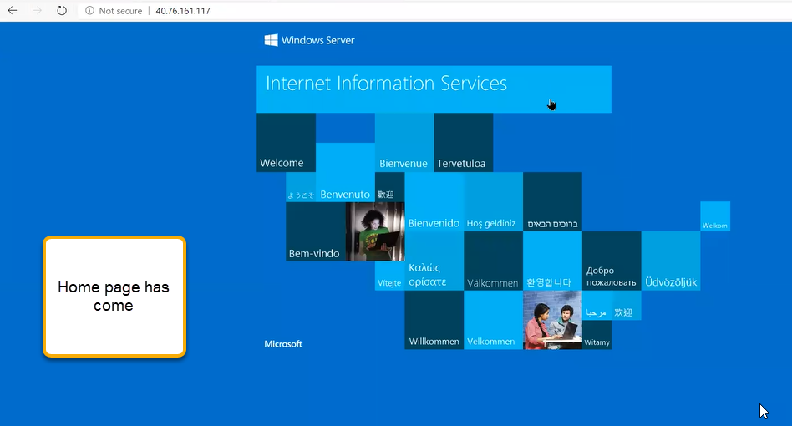

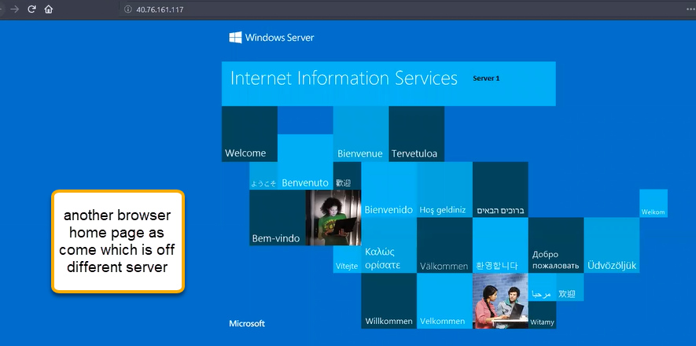

We need to make sure that we have to create the HTTP in all the VMS which linked to application gateway since we have mapped to http protocol

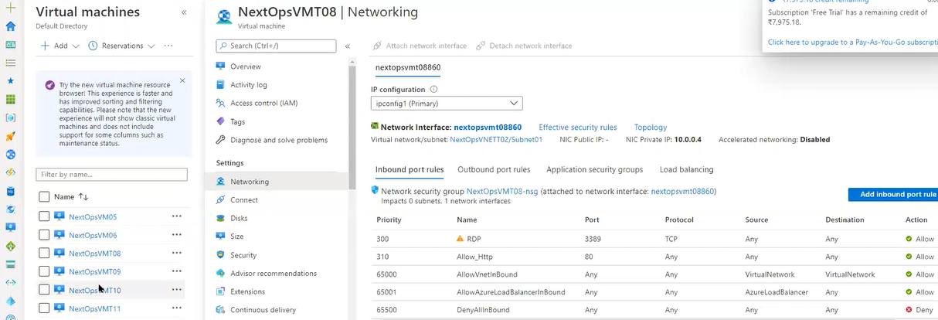

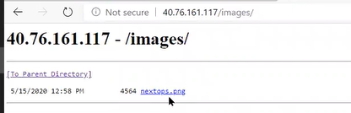

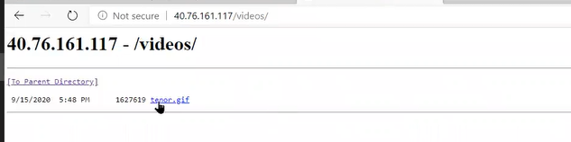

We are already using the port 80 and hosting the website. If you want to use the same port then we need to Add listener and add multi site and add the port number 80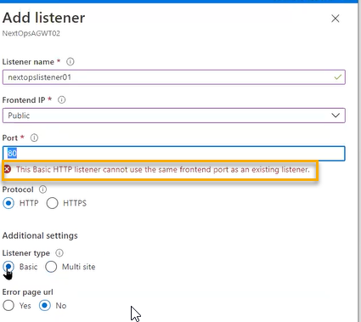

If you create the multisite then host name will be defined which is hostnamedbased routing. User requests coming and going to backend pool in listener configuration we are giving the host name ( to identity the request coming from user after recognising the request it is going to backend pool in the backend pool also IAAS Configuration ( internet admin..) we will mention the URL in the both places we have same url there is no need of additional configuration if any url is in public and in internal IAS if we use internally then we will use [www.tamil.local](http://www.tamil.local) ( the requests coming from end user it has to forward to this URL and we will translate or override. Internal URL does not want to expose and outside it will use.com ( if you select host name override option as override with specific domain name scenario is if public url is [www.tamil.com](http://www.tamil.com) where as internal url is [www.tamil.local.com](http://www.tamil.local.com) then Ii will forward the request form public url to internal url ) if you enable host name the health probes will be automatically connected

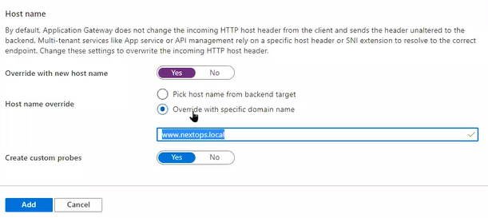

In that case health probes are automtically created.

Single application gateway can support multiple websites

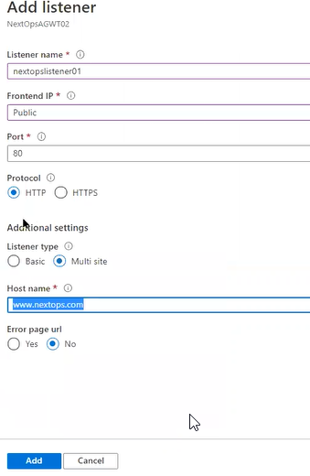

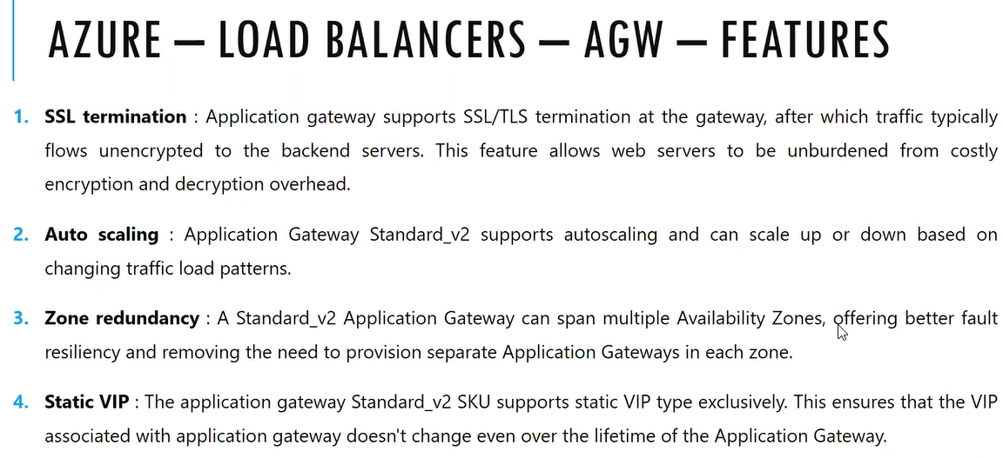

SSL Termination ( Encryption and Decryption will handle at application gateway NOT at the Backend pool) which is built in feature for Application gateway. )

--Not so important----

we can pressure the backend instances for encryption and decryption

Website is hosting in the backend instances. If its HTTP protocol, then no need of certificate for HTTPS we need certificate. For every server we will insert the certificate the each coming request it will encrypt and decrypt on the webserver, so it is overhead to server. Half loading, we can handover to load balancing, decryption, and encryption totally application gateway will handle. Backend servers forwarding traffic will send as unencrypted so performance will be improved it is built in feature. Application gateway will encrypt and forward to end user

